Spindle Torus
# Source: AI Source: Provided by: [Data Path: Persons Table -> ID Column: 1, Name_En Column: Motasem Essam] -> From: [ChatGPT] on [7/20/2026]
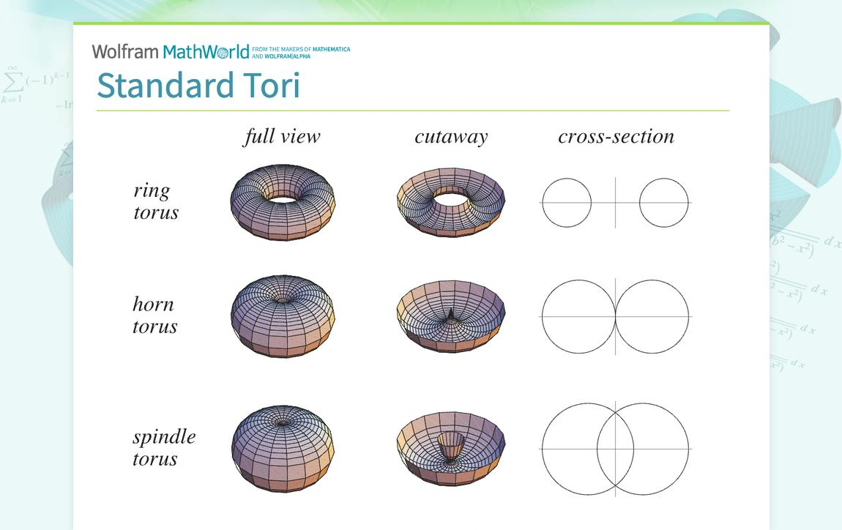
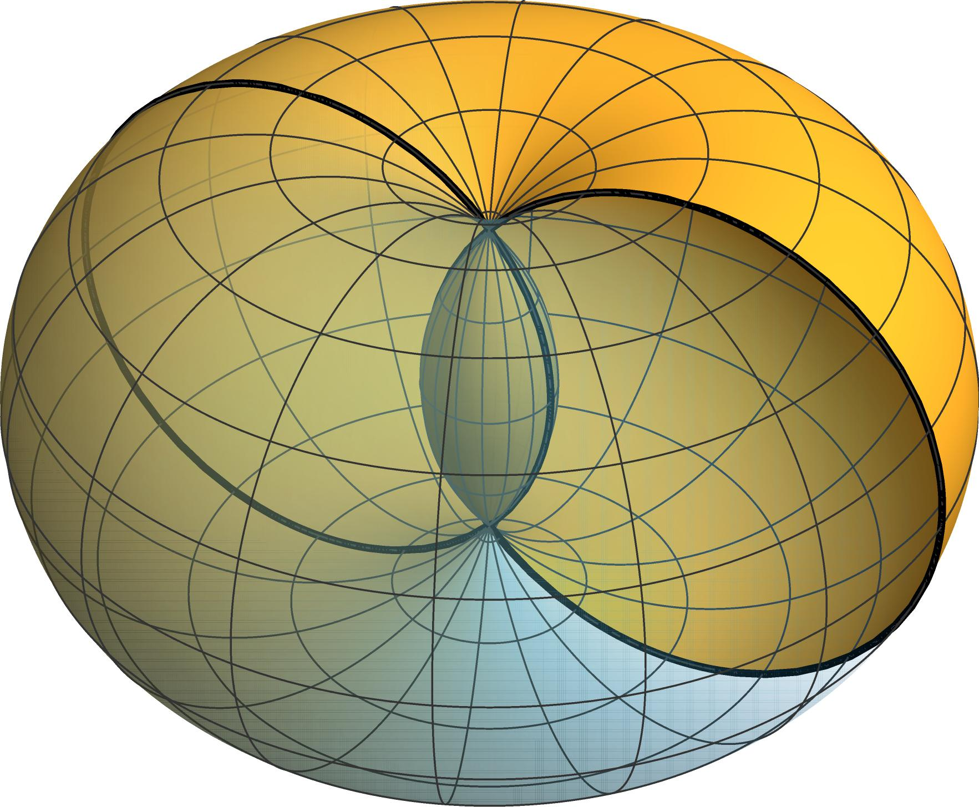
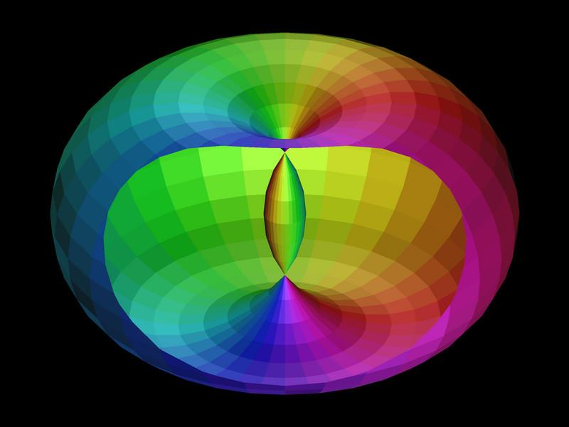
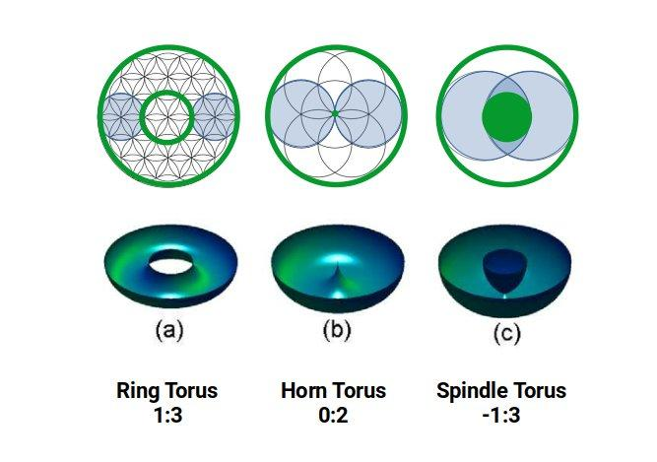
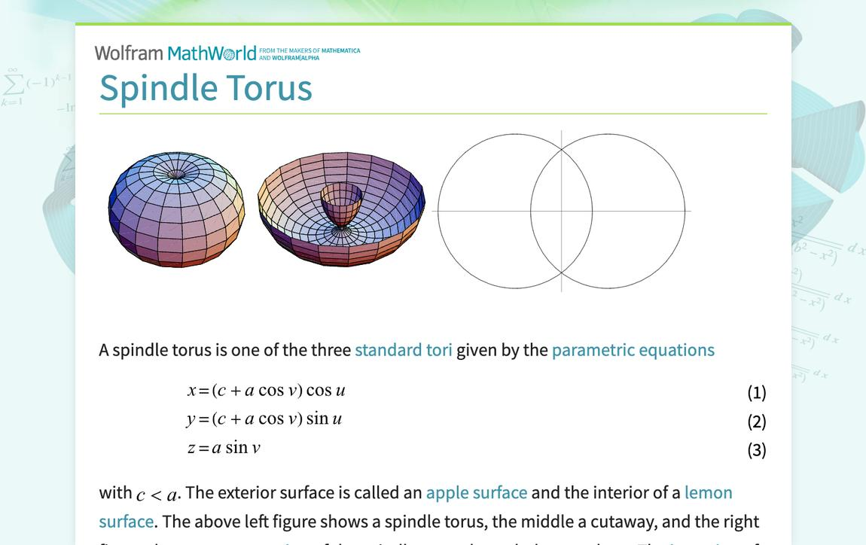

Definition
# Source: AI Source: Provided by: [Data Path: Persons Table -> ID Column: 1, Name_En Column: Motasem Essam] -> From: [ChatGPT] on [7/20/2026]
A Spindle Torus is a type of toroidal surface formed by rotating a circle around an axis in the same plane as the circle when the axis passes through the circle.
It is characterized by:
$$\boxed{R<r}$$
where:
- $R$= major radius, the distance from the axis of rotation to the center of the generating circle.
- $r$= minor radius, the radius of the generating circle.
Because $R<r$, the generating circle intersects the axis of rotation at two points. When the circle is rotated, the resulting surface develops a self-intersecting region.
The three standard circular torus cases are therefore:
$$\boxed{\begin{aligned}R>r&→\text{Ring Torus} \\ R=r&→\text{Horn Torus} \\ R<r&→\text{Spindle Torus}\end{aligned}}$$

Purpose
# Source: AI Source: Provided by: [Data Path: Persons Table -> ID Column: 1, Name_En Column: Motasem Essam] -> From: [ChatGPT] on [7/20/2026]
The spindle torus is useful for:
- Studying special toroidal surfaces.
- Understanding surfaces of revolution.
- Studying the transition from a horn torus to a spindle torus.
- Studying self-intersecting surfaces.
- Exploring topology and differential geometry.
- Computer graphics and geometric modeling.
- Understanding how the relationship between $R$and $r$changes the shape of a torus.

Fundamental Elements
# Source: AI Source: Provided by: [Data Path: Persons Table -> ID Column: 1, Name_En Column: Motasem Essam] -> From: [ChatGPT] on [7/20/2026]
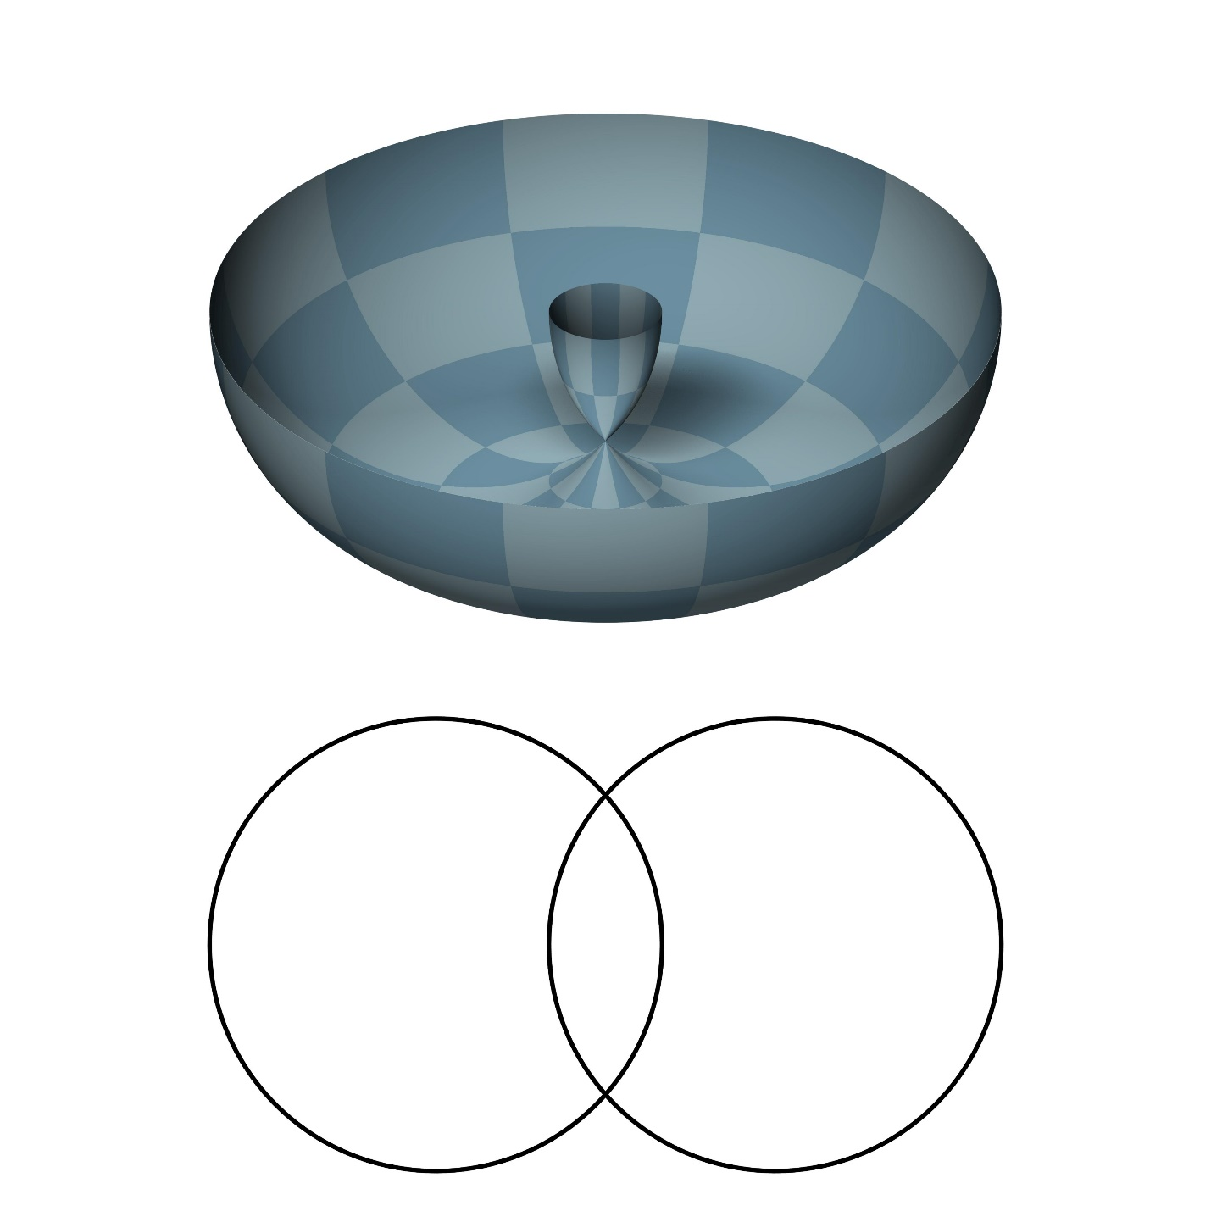

1. Major Radius $R$
# Source: AI Source: Provided by: [Data Path: Persons Table -> ID Column: 1, Name_En Column: Motasem Essam] -> From: [ChatGPT] on [7/20/2026]
The major radius is the distance from the axis of rotation to the center of the generating circle.

2. Minor Radius $r$
# Source: AI Source: Provided by: [Data Path: Persons Table -> ID Column: 1, Name_En Column: Motasem Essam] -> From: [ChatGPT] on [7/20/2026]
The minor radius is the radius of the generating circle.
For a spindle torus:
$$\boxed{R<r}$$

3. Axis of Rotation
# Source: AI Source: Provided by: [Data Path: Persons Table -> ID Column: 1, Name_En Column: Motasem Essam] -> From: [ChatGPT] on [7/20/2026]
The line around which the generating circle is rotated.

4. Generating Circle
# Source: AI Source: Provided by: [Data Path: Persons Table -> ID Column: 1, Name_En Column: Motasem Essam] -> From: [ChatGPT] on [7/20/2026]
The circle that generates the toroidal surface.
Because $R<r$, this circle intersects the axis of rotation at two points.

5. Self-Intersection Circle
# Source: AI Source: Provided by: [Data Path: Persons Table -> ID Column: 1, Name_En Column: Motasem Essam] -> From: [ChatGPT] on [7/20/2026]
When the generating circle is rotated, the two intersection points sweep around the axis and produce a circle of self-intersection.
This is an important feature distinguishing a spindle torus from a ring torus and a horn torus.

Mathematical Representation
# Source: AI Source: Provided by: [Data Path: Persons Table -> ID Column: 1, Name_En Column: Motasem Essam] -> From: [ChatGPT] on [7/20/2026]
Standard Torus Equation
A toroidal surface generated by rotating a circle around the $z$-axis is represented by:
$${\left(\sqrt{x^{2}+y^{2}}-R\right)}^{2}+z^{2}=r^{2}$$
For a spindle torus:
$$\boxed{R<r}$$
Thus, the same equation describes the surface, but with the parameter condition $R<r$.
An equivalent polynomial equation is:
$$\boxed{{\left(x^{2}+y^{2}+z^{2}+R^{2}-r^{2}\right)}^{2}=4R^{2}\left(x^{2}+y^{2}\right)}$$

Parametric Representation
# Source: AI Source: Provided by: [Data Path: Persons Table -> ID Column: 1, Name_En Column: Motasem Essam] -> From: [ChatGPT] on [7/20/2026]
A spindle torus can be represented parametrically by:
$$x=\left(R+r\cos{v}\right)\cos{u} \\ y=\left(R+r\cos{v}\right)\sin{u} \\ z=r\sin{v}$$
where:
$$0≤u<2π$$
and
$$0≤v<2π$$
The condition for a spindle torus is:
$$\boxed{R<r}$$
When:
$$R+r\cos{v}=0$$
the parametrization reaches the axis of rotation. This occurs because $R/r<1$, producing the self-intersection behavior.

Geometric Structure
# Source: AI Source: Provided by: [Data Path: Persons Table -> ID Column: 1, Name_En Column: Motasem Essam] -> From: [ChatGPT] on [7/20/2026]
The defining relationship is:
$$\boxed{R<r}$$
Therefore, the generating circle is large enough to cross the axis of rotation.
When the circle rotates:
- The generating circle crosses the axis.
- Each intersection point traces the axis itself at that instant.
- Under rotation, the corresponding points generate a circle.
- The resulting toroidal surface intersects itself along that circle.
This gives the spindle torus its characteristic pinched and self-intersecting appearance.

Self-Intersection
# Source: AI Source: Provided by: [Data Path: Persons Table -> ID Column: 1, Name_En Column: Motasem Essam] -> From: [ChatGPT] on [7/20/2026]
For a spindle torus, the generating circle intersects the axis at two points.
From the cross-section:
$$ρ=R+r\cos{v}$$
where:
$$ρ=\sqrt{x^{2}+y^{2}}$$
The surface reaches the axis when:
$$ρ=0$$
so:
$$R+r\cos{v}=0$$
Therefore:
$$\cos{v}=-\frac{R}{r}$$
Since:
$$R<r$$
we have:
$$0<\frac{R}{r}<1$$
and the equation has two solutions.
These two points in the generating circle correspond to the self-intersection circle of the spindle torus after revolution.

Surface Area
# Source: AI Source: Provided by: [Data Path: Persons Table -> ID Column: 1, Name_En Column: Motasem Essam] -> From: [ChatGPT] on [7/20/2026]
The familiar torus surface-area formula is:
$$A=4π^{2}Rr$$
However, for a spindle torus, this formula requires an important qualification.
Because the parametrized surface overlaps itself, $4π^{2}Rr$gives the parametric surface area with multiplicity rather than necessarily the area of the distinct geometric surface after overlapping portions are counted only once.
Therefore, for a knowledge base, it is better to state:
$$\boxed{A_{\text{parametric}}=4π^{2}Rr}$$
while noting that the area of the distinct visible/self-overlapping surface requires a specified convention.

Volume
# Source: AI Source: Provided by: [Data Path: Persons Table -> ID Column: 1, Name_En Column: Motasem Essam] -> From: [ChatGPT] on [7/20/2026]
The usual torus volume formula is:
$$V=2π^{2}Rr^{2}$$
But for a spindle torus, this expression also requires care because the generated region overlaps itself.
Using the standard signed/parametric interpretation:
$$\boxed{V_{\text{signed}}=2π^{2}Rr^{2}}$$
It should not automatically be interpreted as the ordinary volume of the union of the enclosed regions.
For the physical volume of the non-overlapping spindle-shaped region, the geometry must be specified and calculated separately.

Example
# Source: AI Source: Provided by: [Data Path: Persons Table -> ID Column: 1, Name_En Column: Motasem Essam] -> From: [ChatGPT] on [7/20/2026]
Suppose:
$$R=4\text{ cm}$$
and:
$$r=6\text{ cm}$$
Since:
$$4<6$$
we have:
$$\boxed{R<r}$$
Therefore, the surface is a spindle torus.
Parametric Surface
$$x=\left(4+6\cos{v}\right)\cos{u} \\ y=\left(4+6\cos{v}\right)\sin{u} \\ z=6\sin{v}$$
Parametric Surface Area
$$A=4π^{2}Rr \\ A=4π^{2}\left(4\right)\left(6\right) \\ \boxed{A=96π^{2}{\text{ cm}}^{2}}$$
Approximately:
$$\boxed{A≈947.48{\text{ cm}}^{2}}$$
Again, this is the parametric area interpretation; because the surface overlaps itself, it should not automatically be treated as the area of the unique geometric union.

Main Properties
# Source: AI Source: Provided by: [Data Path: Persons Table -> ID Column: 1, Name_En Column: Motasem Essam] -> From: [ChatGPT] on [7/20/2026]
- It is a toroidal surface.
- It is a curved surface.
- It is generated by rotating a circle.
- Its defining condition is:
$$\boxed{R<r}$$
- The generating circle intersects the axis of rotation.
- The resulting surface has a self-intersection circle.
- The central hole of a ring torus disappears.
- It has rotational symmetry about the axis.
- The standard torus parametrization can still be used.
- Surface area and volume formulas require special interpretation because of self-overlap.
- It is a special case of a surface of revolution.

Ring Torus vs Horn Torus vs Spindle Torus
# Source: AI Source: Provided by: [Data Path: Persons Table -> ID Column: 1, Name_En Column: Motasem Essam] -> From: [ChatGPT] on [7/20/2026]
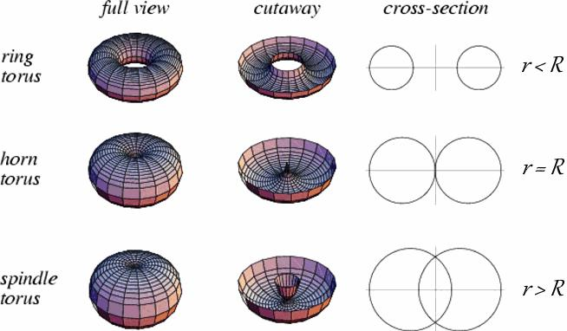
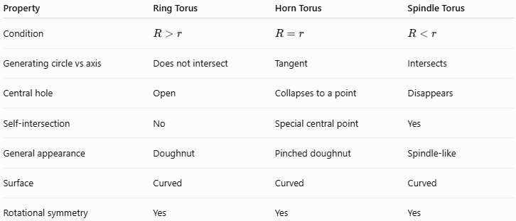
Property | Ring Torus | Horn Torus | Spindle Torus
Condition | $$R>r$$ | $$R=r$$ | $$R<r$$
Generating circle vs axis | Does not intersect | Tangent | Intersects
Central hole | Open | Collapses to a point | Disappears
Self-intersection | No | Special central point | Yes
General appearance | Doughnut | Pinched doughnut | Spindle-like
Surface | Curved | Curved | Curved
Rotational symmetry | Yes | Yes | Yes

Relationship with Horn Torus
# Source: AI Source: Provided by: [Data Path: Persons Table -> ID Column: 1, Name_En Column: Motasem Essam] -> From: [ChatGPT] on [7/20/2026]
The spindle torus can be understood as the continuation of the horn-torus case when the minor radius becomes larger than the major radius.
$$R>r → R=r → R<r$$
Thus:
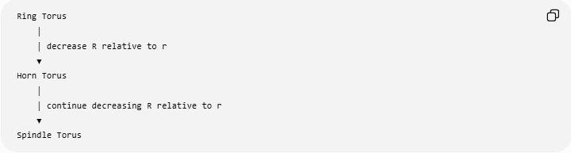
Ring Torus
│
│ decrease R relative to r
▼
Horn Torus
│
│ continue decreasing R relative to r
▼
Spindle Torus
The horn torus is the boundary case:
$$R=r$$
while the spindle torus satisfies:
$$R<r$$

Relationship with Toroidal Surfaces
# Source: AI Source: Provided by: [Data Path: Persons Table -> ID Column: 1, Name_En Column: Motasem Essam] -> From: [ChatGPT] on [7/20/2026]
The classification is:
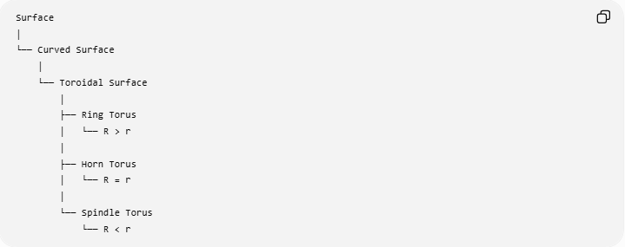
Surface
│
└── Curved Surface
│
└── Toroidal Surface
│
├── Ring Torus
│ └── R > r
│
├── Horn Torus
│ └── R = r
│
└── Spindle Torus
└── R < r
Therefore:
$$\boxed{\text{Spindle Torus}⊂\text{Toroidal Surface}⊂\text{Curved Surface}}$$
It is also a closed toroidal surface in the parametrized sense, but its self-intersection means that statements about enclosed regions and ordinary volume require care.

Real-World and Mathematical Applications
# Source: AI Source: Provided by: [Data Path: Persons Table -> ID Column: 1, Name_En Column: Motasem Essam] -> From: [ChatGPT] on [7/20/2026]
- Differential geometry.
- Topology.
- Surface-of-revolution studies.
- Computer graphics.
- CAD and geometric modeling.
- Mathematical visualization.
- Studies of self-intersecting surfaces.
- Modeling specialized rotational geometries.

Advantages
# Source: AI Source: Provided by: [Data Path: Persons Table -> ID Column: 1, Name_En Column: Motasem Essam] -> From: [ChatGPT] on [7/20/2026]
- Provides an important special case of toroidal geometry.
- Clearly demonstrates how changing $R/r$changes the topology and appearance of a torus.
- Useful for studying self-intersection.
- Has a convenient parametric representation.
- Connects ring, horn, and spindle torus classifications.

Limitations
# Source: AI Source: Provided by: [Data Path: Persons Table -> ID Column: 1, Name_En Column: Motasem Essam] -> From: [ChatGPT] on [7/20/2026]
- The surface self-intersects, making its geometry more complicated than a ring torus.
- Ordinary notions of enclosed volume can become ambiguous.
- The standard torus area and volume formulas require interpretation.
- It is less common in ordinary physical objects.
- Calculations involving the self-intersection require careful specification of the intended region or measurement convention.

Key Points
# Source: AI Source: Provided by: [Data Path: Persons Table -> ID Column: 1, Name_En Column: Motasem Essam] -> From: [ChatGPT] on [7/20/2026]
- A Spindle Torus is a special type of toroidal surface.
- Its defining condition is:
$$\boxed{R<r}$$
- The generating circle intersects the axis of rotation.
- The resulting surface has a self-intersection circle.
- It has no central hole like a ring torus.
- The three standard cases are:
$$\boxed{R>r→\text{Ring Torus}} \\ \boxed{R=r→\text{Horn Torus}} \\ \boxed{R<r→\text{Spindle Torus}}$$
- The standard parametric representation is:
$$\boxed{\begin{aligned}x&=\left(R+r\cos{v}\right)\cos{u} \\ y&=\left(R+r\cos{v}\right)\sin{u} \\ z&=r\sin{v}\end{aligned}}$$
- Surface-area and volume formulas require special care because the surface overlaps itself.

Conclusion
# Source: AI Source: Provided by: [Data Path: Persons Table -> ID Column: 1, Name_En Column: Motasem Essam] -> From: [ChatGPT] on [7/20/2026]
A Spindle Torus is the toroidal surface obtained by rotating a circle around an axis in its plane when the minor radius is greater than the major radius, $R<r$. The generating circle crosses the axis of rotation, producing a self-intersecting toroidal surface with a characteristic spindle-like shape.
It represents the third major case in the classification of circular toroidal surfaces:
$$\boxed{\text{Ring Torus }\left(R>r\right)→\text{Horn Torus }\left(R=r\right)→\text{Spindle Torus }\left(R<r\right)}$$
Would you like the next entry to cover the elliptic torus or the self-intersection geometry in more detail?

